

POC Preparation Checklist for unknown

IBM Instana & DBmarlin
This document helps to prepare for the DBmarlin component of an Instana POC that has a database requirement.

Version: V1.3
Date: 6th May 2025

The POC (Proof of concept) is the opportunity for your prospective customer to validate the capability of IBM Instana and DBmarlin by showing that it generates measurable results and helps the business achieve specific objectives through a pilot or limited implementation.

The definition of use cases is very important. These need to be agreed with the customer, and there should be
- Specific and easy to prove
- Applicable to business problems that the prospective customer has discussed with you
- Achievable for a standard installation of Instana and DBmarlin

This document covers the following points:
- Understanding the People, the High Level goals and Business Services that will be positively impacted.
- Defining an implementation plan for
  - DBmarlin installation
    - Server Installation
    - Agent Installation (not included for POC)
    - Adding Databases to be monitored
    - Monitoring host metrics e.g. (CPU, Memory, IO Utilization)
    - Configuring integration to Instana
    - Configuring integration with other tools
- This document won’t reproduce the standard DBmarlin docs, but it will refer to them

The Prospective Customer

Customer Details
Customer Name | unknown
Region / Dept | unknown
People Details
POC Sponsor | unknown  The person with the overall authority in the buying decision
Champion | Unknown  The technical sponsor
Individual Stakeholders | ………..  Potential users of DBmarlin. DBmarlin’s ease of use means that it isn’t just DBAs that would use it. The appendix shows other potential users for DBmarlin, and the value it provides them. For these users, please include job title, department and responsibilities (especially supported business services).
IBM Instana Team and partners | Include names and job titles
AP DBmarlin Team | Russell Luke, Director  Mick McGuinness, Product Manager
Timescales | Unknown  Expected duration
Start Time | Unknown
DBmarlin deployment | Unknown  We can help you get DBmarlin successfully deployed.
Start of tests | TBD
Presentation of Results | TBD

Implementation Plan
The DBmarlin architecture is described here

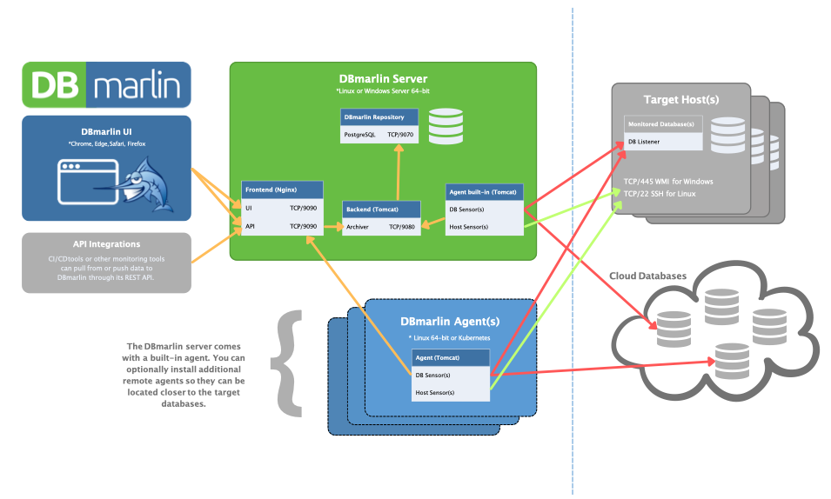

The DBmarlin server runs on Linux (RHEL 8.x & 9.x, Centos 8.x & 9.x, Rocky 8.x & 9.x, Oracle Linux 8.x & 9.x, Ubuntu +20.04, Amazon Linux 2 or 2023) or Windows (Windows Server 2019, 2022, Windows 10) as described here

The link for downloading DBmarlin is here

The recommendation for a PoC is that the deployment happens to a selection of databases, rather than the full deployment. The benefit is that it will speed up the deployment, and allow more time for testing. The selection should be representative of the full estate.

DBmarlin does not need an agent or any software to be installed on the hosts or databases being monitored. The simplest setup for DBmarlin is to have a single VM which runs all the DBmarlin components (UI, APIs, Repository DB and a built-in Agent). For POCs this is almost always all that is required. The agent just needs connectivity over the network to connect to the target databases using a regular database connection to the database listener port.

For a PoC, you will probably not need to install a separate DBmarlin agent. Additional agents are there to support scale out to +100 monitored DB instances or in cases where you need to monitor DBs that are distributed across data centers or cloud providers and have them report to a central DBmarlin server.

The sizing guide can be used to determine the required server size for the POC:

Profile | #Monitored Databases | Compute | Memory | Disk Storage | AWS EC2 instance
XSmall | 1 | 1 vCPUs | 2GB | 20GB Free | t3a.small
Small | <5 | 1 vCPUs | 4GB | 100GB Free | t3a.medium
Medium | <20 | 2 vCPUs | 8GB | 400GB Free | t3a.large
Large | <50 | 4 vCPUs | 16GB | 1TB Free | t3a.xlarge
XLarge | <100 | 8 vCPUs | 32GB | 2TB Free | t3a.2xlarge

The AWS EC2 instance type was calculated as of 6th May 2026. The actual instance type may vary depending on changes that Amazon make. The AMD version is recommended as it is approximately 10% cheaper than Intel.

Once the server is provisioned, we can provide a license given the MAC address, number of instances / databases and timescale.

Configuration of database monitoring is covered under the “Monitored Technologies” -> “Databases” -> “Database Type”. For example, Oracle is covered here. It is good to get approval for the requirements for each database type that is monitored to ensure that there are no delays or objections.

Configuration of Host monitoring is covered for AWS RDS, Linux and Windows.

The Instana integration requires a name (to identify the Instana instance), Host Address and API Key for Instana (available within Instana). The documentation is here

Evaluation Criteria
Application Performance has now created a cookbook. This provides a clear way to get used to DBmarlin. The “recipes” in the cook book are based on solving problems. Take a look at the table of contents, and this will provide an excellent place to start. The cookbook should also be attached.

The following evaluation criteria can be used to record how well the product measures against your requirements. These criteria should be reviewed and modified to better suit your requirements.

Evaluation Criteria | Why this criteria is important | Result
The ability to determine root cause for database query performance problems | IBM Instana and other APM tools can identify that the database is causing a problem. DBmarlin can show you the root cause.  Rapid and precise identification of the root cause can reduce the MTTR (mean time to repair) and therefore increase availability of the business applications supported by the database.
The ability to correlate performance issues with recent database changes | Gartner estimates that 85% of all performance incidents can be traced back to change.  DBmarlin can show recent changes, and the effect on database execution either by database wait states, query execution plans or index changes for example can help rapid diagnosis.  Rapid and precise identification of the root cause can reduce the MTTR (mean time to repair) and therefore increase availability of the business applications supported by the database.
Analysis of wait events | Databases spend most of their time either executing work or waiting for resources (I/O, locks, CPU, memory). If you only look at query execution time, you see the symptom (slowness), but not the cause (e.g. waiting for a lock)  Wait analysis gives visibility across either the whole instance or for a specific query, showing whether performance issues are caused by:  * CPU contention  * Disk I/O (slow reads/writes, storage bottlenecks)  * Locks and latches (issues with concurrency)  * Network waits (latency between app and DB)
Analysis of SQL statistics | SQL Statistics are essential performance metrics that help in analysing and optimising the performance of SQL queries and database systems. These statistics provide insights into how the database engine processes SQL statements, enabling database administrators and developers to identify performance bottlenecks and optimize query execution.
The ability to gather query performance metrics from a database | Query analysis can help  1. identify performance bottlenecks  2. Optimise resource usage  3. Support troubleshooting and root cause analysis  4. Analysing the data over time to identify trends and remediate before it is noticeable to end users.  5. Faster queries can make the application more responsive for the end user  6. Query analysis can help with cost control. In the cloud, inefficient queries can drive up compute costs. When working with on premises servers, the database can be moved to a less expensive server without performance degradation  7. Query analysis (and trending) can provide accurate historical data to provide a data driven approach for Capacity planning and scaling.
The ability to gather infrastructure performance metrics from a database | Infrastructure metrics can be a powerful guide when tuning database performance because databases don't operate in isolation - they depend heavily on the health of the underlying compute, storage and network layers. By correlating infrastructure behaviour with database activity, you can often pinpoint root causes and avoid wasted effort tuning SQL or schema design when the real bottleneck lies elsewhere.
The ability to alert when a performance metric breaches a previously generated threshold | Alerting on breach of performance metric thresholds is a key part of effective database monitoring because it gives you timely visibility into conditions that, if left unchecked, degrade query performance and then end-user experience.
The ability to gather metrics to a 1-second granularity. | A 1-second granularity for gathering performance metrics is very powerful, because it provides a level of precision that traditional monitoring (often 15s, 1min or even 5 min) simply cannot match. Many performance issues may only last a few seconds, and could be missed with a higher granularity.  Instana also gathers metrics with a 1-second granularity, so issues detected within Instana should correlate better with the issues detected within DBmarlin.
The ability to take snapshots for a database so as to use them as a basis of comparison at full 1-second granularity for as long as you need it. | Snapshots in DBmarlin allow:  1 - Compare before / after changes  2 - Quickly diagnose root causes  3 - Track performance drift  4 - Share evidence easily with others  5 - Simplify analysis by focusing on differences.
The ability to produce comparison reports for SQL statistics, Database parameters and Query Activity. | Comparison reports in DBmarlin allow:  1 - Compare before / after changes in order to better understand the impact of changes.  2 - Quickly identify root cause by ruling in or out database change as a cause  3 - Track Performance drift - by comparing performance between releases to detect gradual degradation
The ability to integrate alert management with an IT Service or Operations management desk | The integration of alerts into Service or Operations Management tools starts a process whenever an alert is triggered. This speeds up the time to repair, while the ease of use of DBmarlin makes it accessible to more people within operations or service management.
The ability to integrate with Release management, Change management or CI/CD tools to detect and correlate change as a probable cause. | Gartner estimates that 85% of all performance incidents can be traced back to change.  DBmarlin can show recent changes, and the effect on database execution either by database wait states, query execution plans or index changes for example can help rapid diagnosis.  Rapid and precise identification of the root cause can reduce the MTTR (mean time to repair) and therefore increase availability of the business applications supported by the database.
automatic schema change - different event in timeline.
The ability to integrate with Instana and other observability solutions with a one click button to take the user in context to the database query at issue. https://www.dbmarlin.com/dbmarlin-for-instana | IBM Instana and other APM tools can identify that the database is causing a problem. DBmarlin can show you the root cause.  The bi-directional integration with IBM Instana and DBmarlin means that an APM engineer can easily understand possible causes within database tiers for any performance incidents.
The ability to manage all databases of many different types with a single pane of glass | Ever increasing number of database platforms to support -> perform efficiently with minimal FTE's (FTE == full time equivalent employee)
recommendations screen - will advise on license keys expiring, left debug turned on, new feature to enable etc.
at object level - object statistics - tells about growth etc for object. recommendations, large table with no primary key, foreign key column that doesn't have an index
The ability to provide easy to comprehend documentation to help with diagnosis and remediation options, available at a click within the user interface. | Documentation and recommendations for each supported database platform can reduce time taken to identify the root cause as well as providing possible remediation options. This is especially useful when an organisation has to support multiple database platforms.
The ability to provide easy to comprehend diagnosis and remediation instructions generated using Generative AI. | AI LLM models can provide augmented incident recommendations that can reduce time taken to identify the root cause as well as providing possible remediation options.
The ability to provide AI capabilities with a choice of AI LLMs including IBM WatsonX, OpenAI, Microsoft Co-Pilot etc | The choice of AI LLMs available allows you to integrate DBmarlin with your preferred AI engine. It means that the model will be more accurate for your organisation.
execution plans collected automatically close to the time of execution. | The explain plans will reflect the way it worked at the time rather than now, giving more accurate results.  Other products will not store these, but will require the plan to be generated with bind values which need to be provided. This may produce an inaccurate explain plan greatly diminishing the value.

